**State Infant Mortality Rate Pre(2010)/Post(2015) Affordable Care Act**

Susan Jessop, Anjelica Ramsey, Sanjaye Thomas

[Team Github](https://github.com/Sanjaye22/CU-BootCampProject-Two)

**Project Description/Outline**

Infant mortality is defined as the death of an infant before their first birthday. It is used as a broad population indicator of the community’s health status, socioeconomic levels and accessibility to medical services [(AMCHP)](http://www.amchp.org/programsandtopics/data-assessment/InfantMortalityToolkit/Documents/Why%20Focus%20on%20IM.pdf). The Affordable Care Act (ACA) was enacted in 2010 in an effort to decrease the uninsured rate and therefore improve patient outcomes. In our project, we will collect datasets of state infant mortality and uninsured rate pre/post to ACA to access the differences between each state.

**Data Resources**

[Health Insurance Coverage (via Kaggle)](https://www.kaggle.com/hhs/health-insurance)

[Infant Mortality Rates (via CDC)](https://wonder.cdc.gov/lbd-current.html)

[Health System Tracker](https://www.healthsystemtracker.org/chart-collection/infant-mortality-u-s-compare-countries/#item-start)

[Our World in Data](https://ourworldindata.org/child-mortality)

**Team Hurdles:**

* Attaching longitudinal/latitudinal to dataset in order to use leaflet
  + Mapbox (for base maps) - outdoors view
* Manipulating CDC dataset to have infant mortality race rates. Currently the dataset sets race as a “pivot table” rather than its own column
  + Leverage Pandas / Python to clean dataset
* Converting exported json data as CSV into SQL
  + Leverage Jupyter Notebook (i.e., Pandas)
* Base template html with [bootstrap themes](https://colorlib.com/wp/cat/bootstrap/)
* Launch on [Herokuapp.com](https://www.heroku.com/)
  + **Database name:** ddn79un7gs1tf3
  + aca_infant_mortality
* Flask App
  + 4 Routes
    - Home
    - Births – 2010 vs 2015
    - Deaths – 2010 vs 2015
    - Uninsured – 2010 vs 2105
* Procfile – make sure that correspond to the name of your App
* Requirement.txt

**Visualizations**

* Side by Side Bar chart of:
  + Deaths 2010 vs 2015
  + Births 2010 vs 2015
  + Filter to show only 10 – 20
  + Filter option on State
* Line Chart
  + Uninsured Rate 2010 vs 2015
  + filt
* Two US Maps (2010 &2015) with granulated colors according to uninsured rate
* Mouseover event for every state profile
  + Average infant mortality rate
  + Infant mortality rate categorized by race
  + *Leaflet*
* Bar graph time comparison average infant mortality rates for each state with uninsured rate in bar
  + D3
  + Add dropdown menu to display info by state

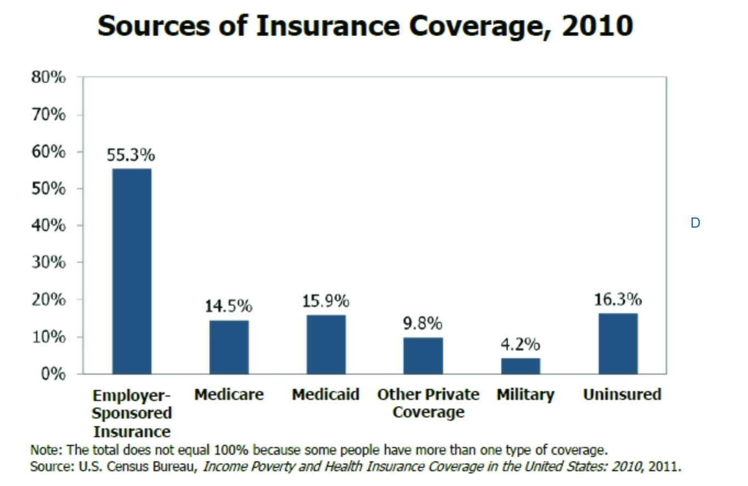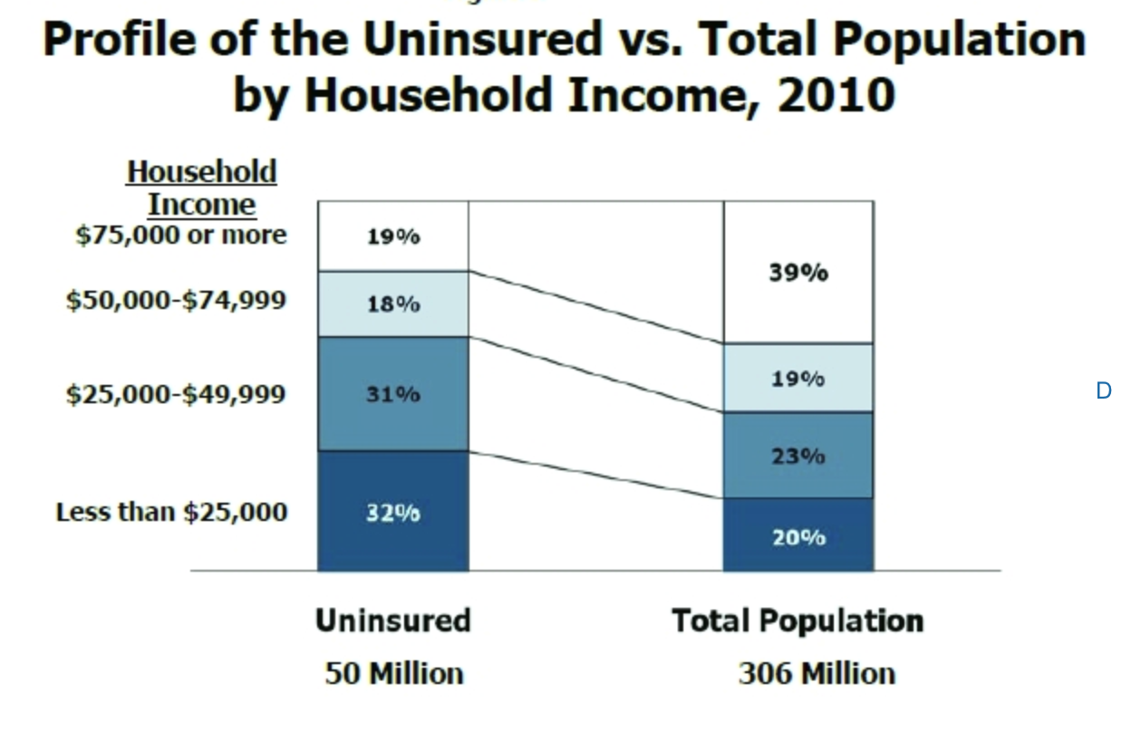

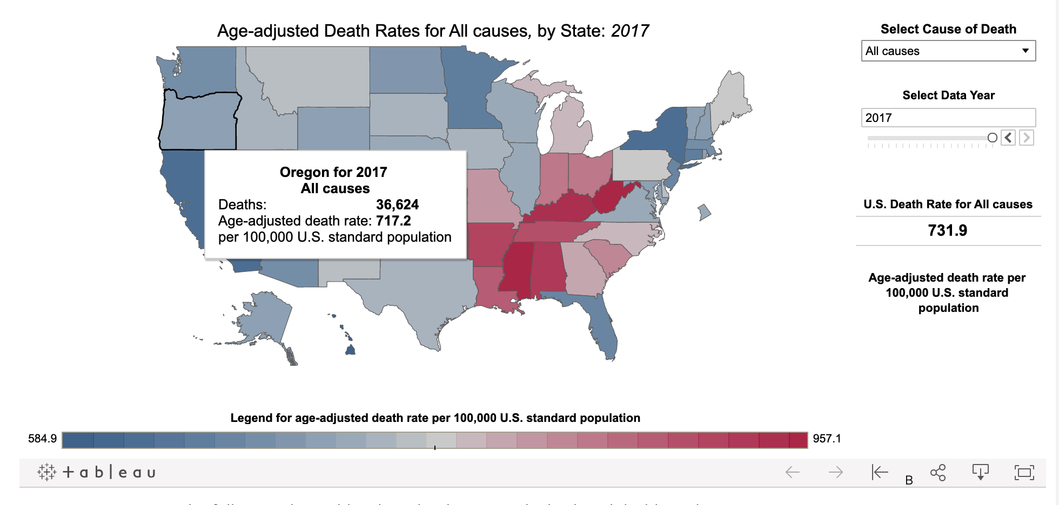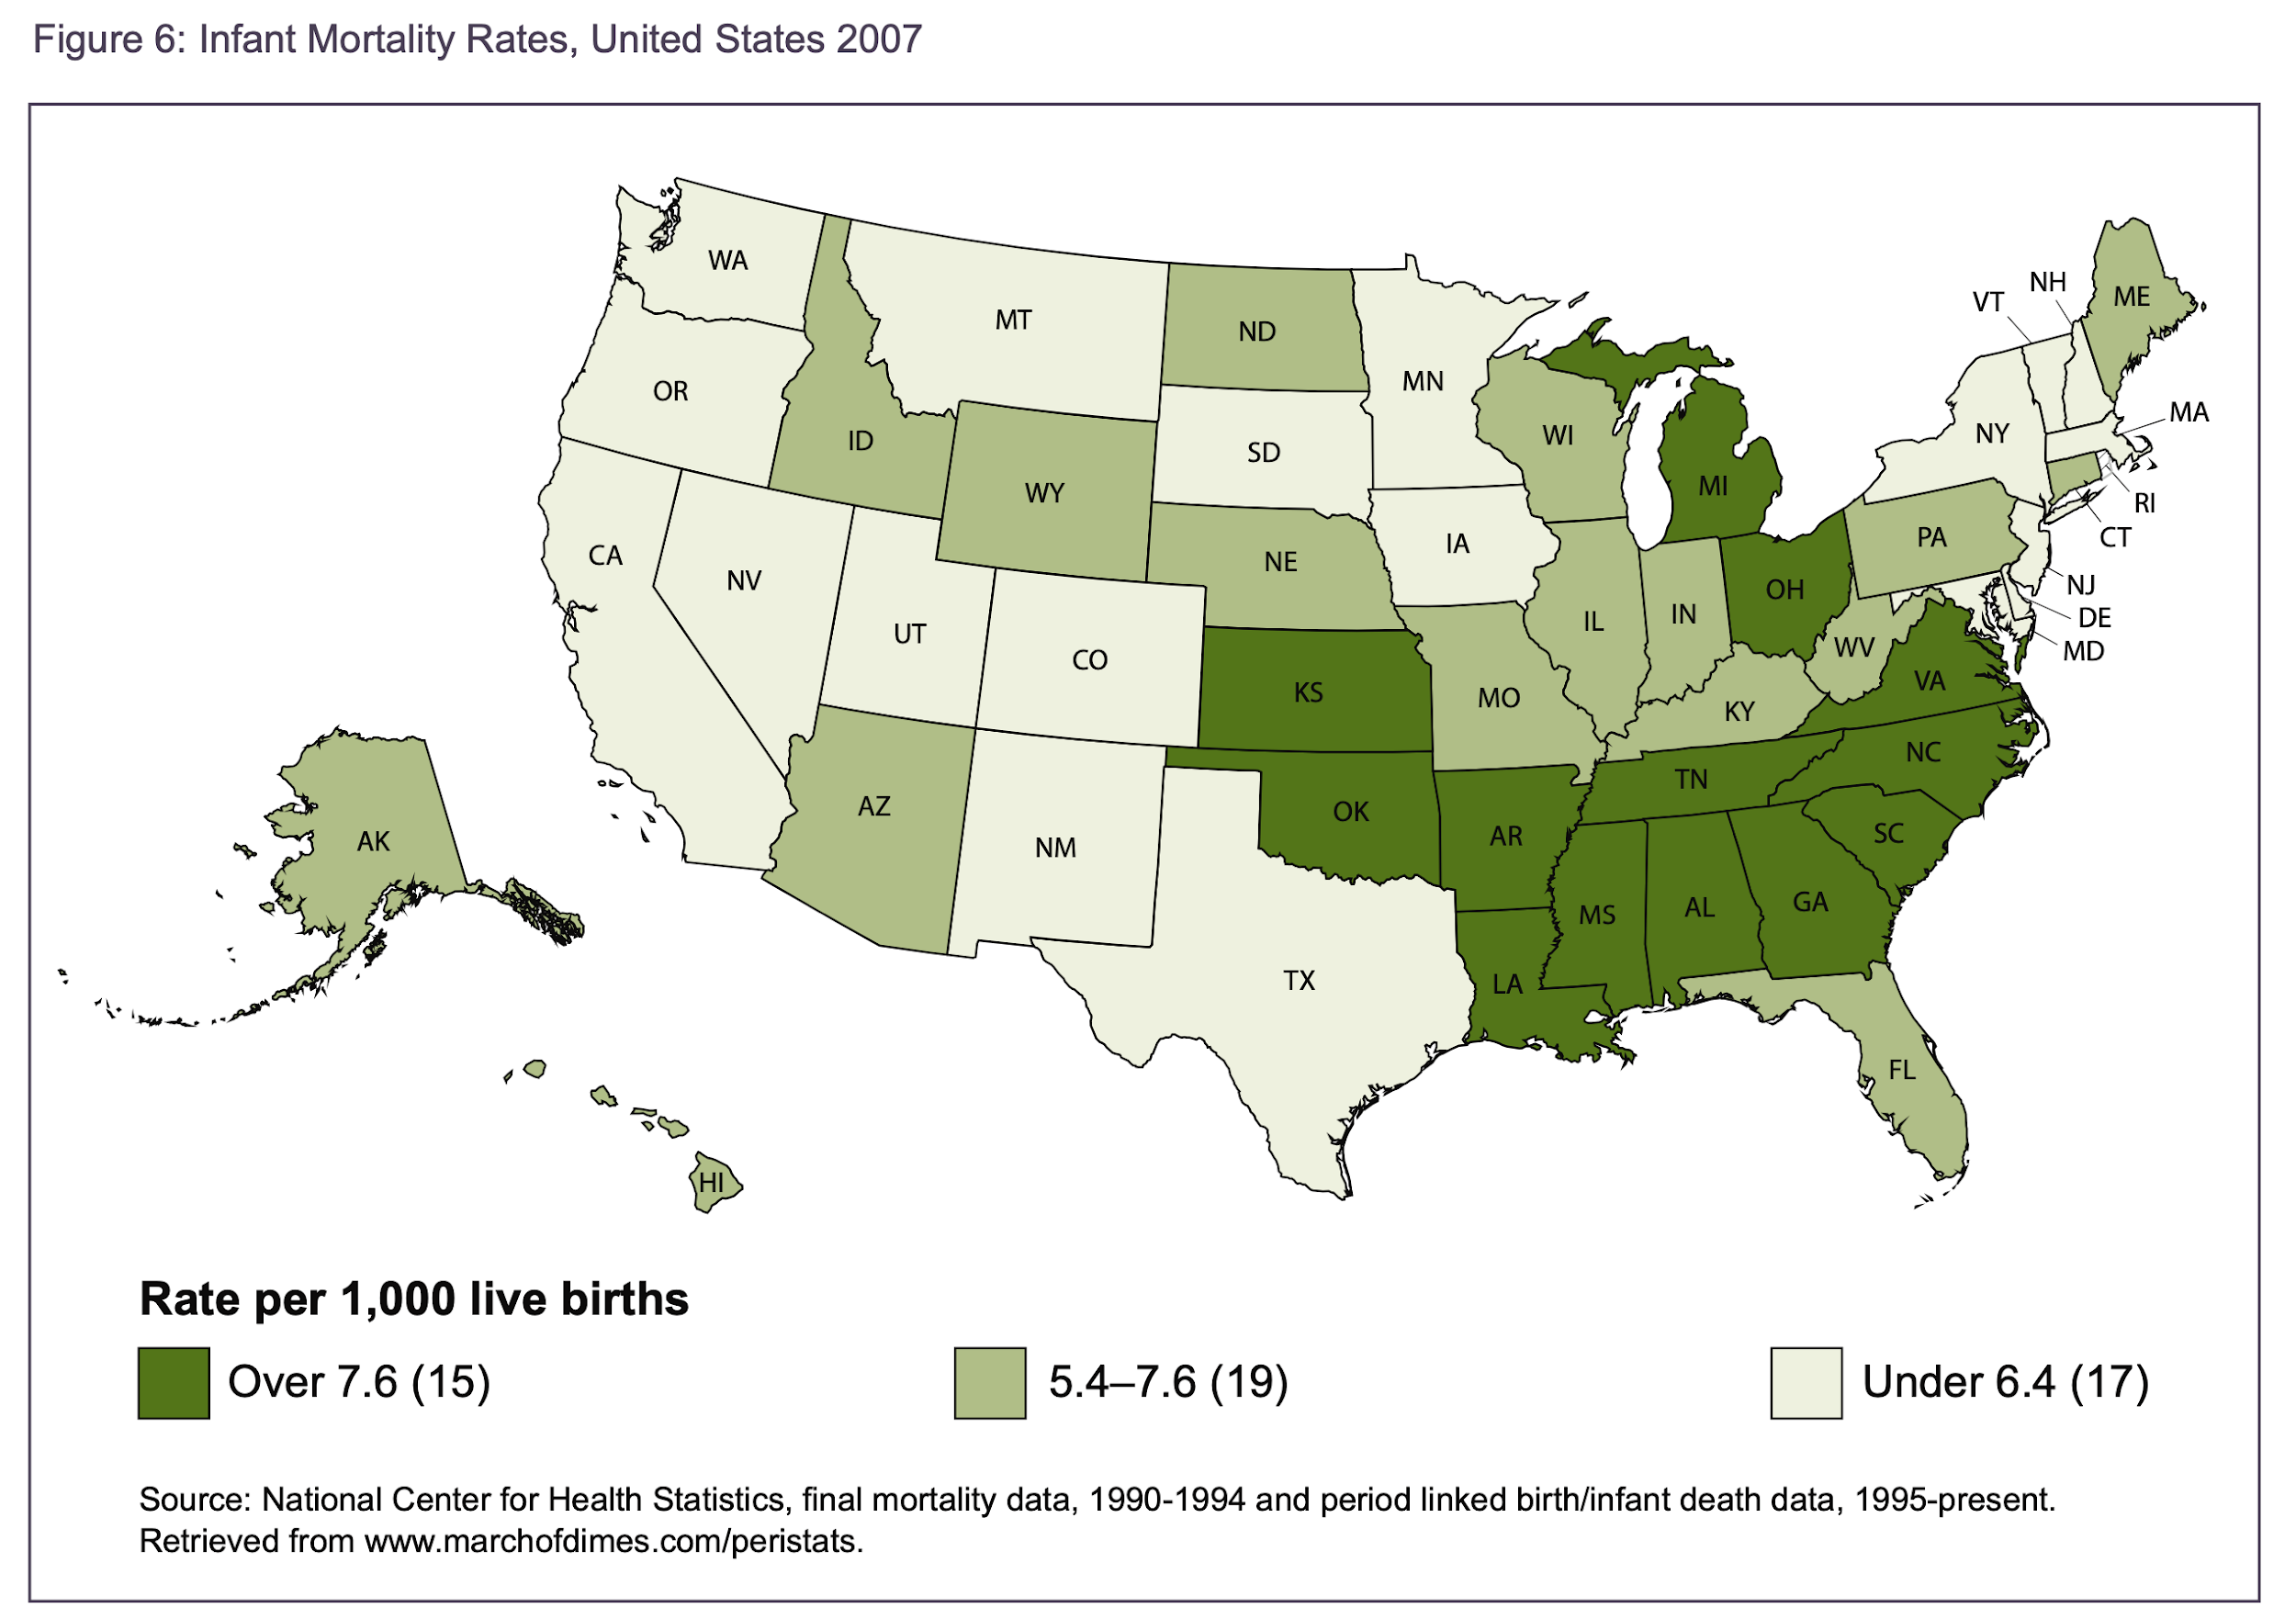

* Pie chart
  + Infant deaths by age of infant at death - 2010 vs 2015
* 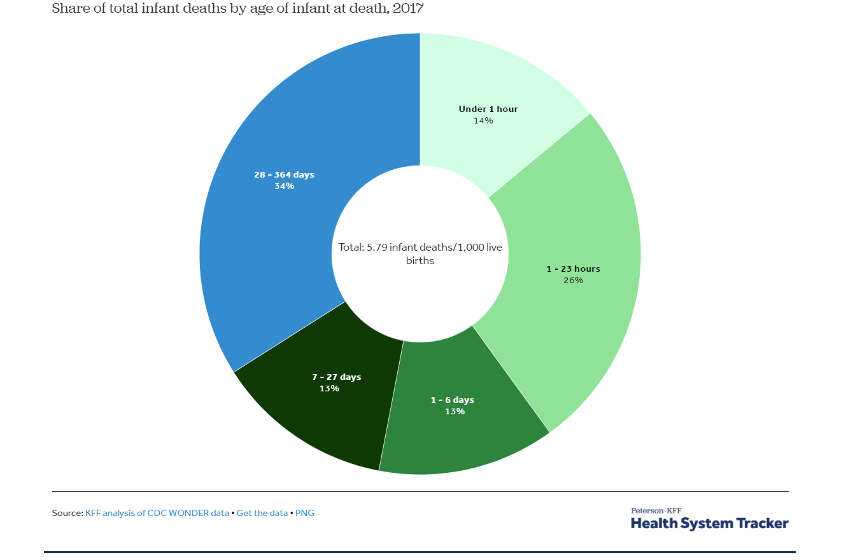
* Other visualization options
  + Infant mortality - US vs Other countries

